Stakeholder Toolkit
2019 Flood Safety and Severe Weather Awareness

Flood Safety and Severe Weather Awareness
The Federal Emergency Management Agency (FEMA), the Ready Campaign, and The National Oceanic and Atmospheric Administration (NOAA) are teaming up again to highlight the importance of flood safety and severe weather awareness this late winter and spring.
According to the National Weather Service (NWS) in 2017, there were 126 flood fatalities in the United States and flooding caused approximately $60 billion in damages. We ask that this late winter and early spring you promote the importance of understanding your risk, taking action, and being an example where you live.
Severe weather can happen during any season and impact any part of our country. Late-season snowstorms can impact the East Coast and the Northern Plains, thunderstorms rip across the South and Midwest, rivers overflow their banks and heat waves begin in the Southwest. Don’t let this dangerous season catch you unaware. Get ready for severe weather with just a few simple steps: Know Your Risk, Take Action and Be a Force of Nature.
In addition to asking Americans to learn their risks and take action to prepare through its own outreach channels, FEMA Region III is encouraging everyone to get the word out and help the Whole Community prepare for flooding. This toolkit is designed to provide you and your organization with easy to use tools to promote this campaign and help your stakeholders be better prepared for disasters.
For your reference, below are points of contact for the various stakeholder groups.
FEMA Region III points of contact
Public Affairs | William Powell | 215-931-5684
Congressional Affairs | Corey Demuro | 215-931-5715
Intergovernmental Affairs | Corey Demuro | 215-931-5715
Private Sector | Melissa Wiehenstroer | 202-568-4391
Volunteer Agency Liaison | Michelle Breeland | 215-931-5584
Community Preparedness | Amanda Hancher | 215-931-5716
Disability Integration | PJ Mattiacci | 267-270-5804

Talking Points

Key Messages

Flood Awareness
- Flooding is a nationwide threat to the United States and its territories throughout the year. It’s important to for everyone to understand their risk, take action to prepare, and be an example.
- In direct response to so many unnecessary vehicle-related flood deaths, the National Weather Service (NWS) developed a national campaign called “Turn Around Don’t Drown.” The campaign aims to educate motorists of the dangers of driving across flooded roads. To learn more about the campaign and promotional tools, please visit http://www.nws.noaa.gov/os/water/tadd/.

National Severe Weather Awareness
- Know Your Risk: Hurricanes, droughts, floods, tornadoes, thunderstorm winds, hail, lightning, heat, wildfires, rip currents, snowstorms – severe weather impacts every part of the country. The first step to becoming weather-ready is to understand the type of hazardous weather that can affect where you live and work, and how the weather could impact you and your loved ones.
- Take Action: Make an evacuation plan, build an emergency kit or update your existing kit, inventory and keep important papers and valuables in a safe place, and get involved in helping others prepare. You can begin by visiting Community.fema.gov.
- Be an example where you live: Be a helpful influence on your community by sharing your weather preparedness story. Be a Force of Nature by letting your friends and family know what you did to become weather-ready and the steps they can take to do the same.
- In 2018, there were 14 weather and climate disaster events with losses exceeding $1 billion each across the United States. These events included 1 drought event, 8 severe storm events, 2 tropical cyclone events, 1 wildfire event, and 2 winter storm events. Overall, these events resulted in the deaths of 247 people and had significant economic effects on the areas impacted. The 1980–2018 annual average is 6.2 events (CPI-adjusted); the annual average for the most recent 5 years (2014–2018) is 12.6 events (CPI-adjusted).

Know your Risk

Flood Awareness
- According to the National Weather Service (NWS) in 2017, there were 126 flood fatalities in the United States and flooding caused approximately $60 billion in damages.
- Floods are one of the most common hazards in the United States but not all floods are alike. Some floods develop slowly, while others, such as flash floods, can develop in just a few minutes and without visible signs of rain.
- Flash floods can occur within a few minutes or hours of excessive rainfall, a dam or levee failure, or a sudden release of water held by an ice jam.
- Overland flooding, the most common type of flooding event, typically occurs when waterways such as rivers or streams overflow their banks as a result of rainwater or a possible levee breach and cause flooding in surrounding areas. It can also occur when rainfall or snowmelt exceeds the capacity of underground pipes, or streets and drains designed to carry flood water away from urban areas.
- Be aware of flood hazards no matter where you live or work, but especially if you are in low-lying areas, near water, behind a levee, or downstream from a dam. Even very small streams, gullies, creeks, culverts, dry streambeds or low-lying ground that appear harmless in dry weather can flood.
- For information on causes of flooding, visit Ready.gov/floods
- What you can do:
  - Visit Ready.gov/floods to learn more about flooding.
  - Visit FloodSmart.gov to learn about the National Flood Insurance Program
  - Follow @FEMAregion3 on Twitter.
  - Follow FEMA on Facebook and Twitter.
  - Follow the National Weather Service on Facebook and Twitter.

Take Action

Flood Awareness
- To prepare for, and protect against, a flood, you should:
  - Build an emergency kit.
  - Make a family communications plan.
  - Avoid building in a floodplain unless you elevate and reinforce your home.
  - Elevate the furnace, water heater and electric panel in your home if you live in an area that has a high flood risk.
  - Consider installing "check valves" to prevent flood water from backing up into the drains of your home.
  - If feasible, construct barriers to stop floodwater from entering the building and seal walls in basements with waterproofing compounds.
- Know the terms to help understand flood hazard:
  - Flood Watch - Flooding is possible; tune in to NOAA Weather Radio, commercial radio or television for information.
  - Flash Flood Watch - Flash flooding is possible. Be prepared to move to higher ground; listen to NOAA Weather Radio, commercial radio or television for information.
  - Flood Warning - Flooding is occurring or will occur soon; if advised to evacuate, do so immediately.
  - Flash Flood Warning - A flash flood is occurring; seek higher ground on foot immediately.
- Know how to act during flood:
  - Listen to the radio, television, or your Weather Radio for information.
  - Be aware that flash flooding can occur. If there is any possibility of a flash flood, move immediately to higher ground. Do not wait for instructions to move.
  - Be aware of stream, drainage channels, canyons and other areas known to flood suddenly. Flash floods can occur in these areas with or without typical warnings such as rain clouds or heavy rain.
  - If you must prepare to evacuate, you should do the following:
    - Secure your home. If you have time, bring in outdoor furniture. Move essential items to an upper floor.
    - Turn off utilities at the main switches or valves if instructed to do so. Disconnect electrical appliances. Do not touch electrical equipment if you are wet or standing in water.
  - If you have to leave your home, remember these evacuation tips:
    - Do not walk through moving water. Six inches of moving water can make you fall. If you have to walk in water, walk where the water is not moving. Use a stick to check the firmness of the ground in front of you.
    - Do not drive into flooded areas. If floodwaters rise around your car, abandon the car and move to higher ground, when water is not moving or not more than a few inches deep. You and the vehicle can be swept away quickly. If your vehicle is trapped in rapidly moving water, stay in the vehicle. If the water is rising inside the vehicle, seek refuge on the roof.
    - Do not camp or park your vehicle along streams, rivers or creeks, particularly during threatening conditions.
  - If you’re driving;
    - Six inches of water will reach the bottom of most passenger cars causing loss of control and possible stalling.
    - A foot of water will float many vehicles.
    - Two feet of rushing water can carry away most vehicles including sport utility vehicles (SUV’s) and pick-ups.
    - Do not attempt to drive through a flooded road. The depth of water is not always obvious. The road bed may be washed out under the water, and you could be stranded or trapped.
    - Do not drive around a barricade. Barricades are there for your protection. Turn around and go another way.
    - Do not try to take short cuts. They may be blocked. Stick to designated evacuation routes.
    - Be especially cautious driving at night when it is harder to recognize flood dangers.
- Make an Emergency Plan
  - Identify three places to meet family and friends in the event of an emergency. One in your neighborhood, one in your town, and one out of town. Make sure that all locations are in higher elevation and offer protection from the elements.
  - Learn how you will get to your out of town location; determine your evacuation routes.
  - Write down information on important locations like workplaces, schools, daycares, houses of worship, etc.
  - Make sure you take into account everyone’s needs, such as any medical concerns, communications, etc.
  - Know how you will learn important information after a disaster (radio, warning sirens, reverse 911, etc.).
  - Share contact information with everyone (friends, family, and out of town contacts).
Be an Example
Flood Awareness
- Be a positive influence on your community by sharing your preparedness story.
- Building a nation of preparedness requires the action of all of us. Each and every person across the country has the potential to be an example and be ready.
- Studies show that individuals need to receive messages a number of ways before taking appropriate action.
- Most people are more likely to act when the messages they receive are from a trusted source like family, friends, or a community leader.
- Share the actions you’ve taken to be prepared with your family and friends by posting your story on your social media site.
- Tweet that you’re prepared with the hashtag #ImAForce #FloodSafety, #SevereWxPrep #R3Ready, #SpringSafety, and #pr3pared.

- Have an emergency plan, and know what to do before a disaster strikes. Post your plan in your home or business where individuals can see it.
- Find out from local emergency management how you can be notified for each kind of disaster and sign up for additional alerts through social media and local news.

Press Release Template
<ORGANIZATION> Supports Flood Preparedness
<CITY, St.> – <INSERT ORGANIZATION> will be supporting Flood Safety Awareness and encouraging all to know your risk, take action, and be an example where you live.<INSERT ORGANIZATION> is <INSERT EVENT INFORMATION HERE> or <committed to supporting flood preparedness in the community>.
Flooding is a nationwide threat to the United States and its territories throughout the year. However not all floods are alike. Some floods develop slowly, while others, such as flash floods, can develop in just a few minutes and without visible signs of rain. Additionally, floods can be local, impacting a neighborhood or community, or very large, affecting entire river basins and multiple states.
Everyone should be aware of flood hazards no matter where you live or work, but especially if you are in low-lying areas, near water, behind a levee or downstream from a dam. Even very small streams, gullies, creeks, culverts, dry streambeds or low-lying ground that appear harmless in dry weather can flood.
<ORGANIZATION>, alongside Federal Emergency Management Agency (FEMA), and the Ready Campaign will be encouraging <EMPLOYEES OR RESIDENTS> to take action against flooding by:
  - Building an emergency kit and making a family communications plan.
  - Elevating the furnace, water heater and electric panel in your home if you live in an area that has a high flood risk.
  - Holding a discussion, drill, or exercise.

*QUOTE FROM LEADERSHIP TO SUPPORT THE FLOOD PREPARDNESS CAMPAIGN*

More information can be found at <INSERT ORGANIZATION WEBSITE or Ready.gov>. Information on the different types of hazards is available at Ready.gov or the Spanish-language web site Listo.gov.

Press Release Template

<ORGANIZATION> is Encouraging Everyone to “Be a Force of Nature”
Severe Weather Awareness
<CITY, St.> – <INSERT ORGANIZATION> is proud to join and promote the campaign to spread the word and encourage <employees or residents> and the rest of the community to Be a Force of Nature by knowing your risk, taking action, and being an example where you live. <INSERT ORGANIZATION> is <INSERT EVENT INFORMATION HERE> or <committed to being a leader for emergency preparedness>.
The Federal Emergency Management Agency (FEMA), the Ready Campaign, and The National Oceanic and Atmospheric Administration (NOAA) are teaming up again to highlight the importance of preparing for severe weather before it strikes. During this spring take time to learn what hazards may impact you, taking action by making a kit and having a plan, and become an example where you live by sharing your actions.
In 2018, there were 14 weather and climate disaster events with losses exceeding $1 billion each across the United States. These events included 1 drought event, 8 severe storm events, 2 tropical cyclone events, 1 wildfire event, and 2 winter storm events. Overall, these events resulted in the deaths of 247 people and had significant economic effects on the areas impacted. The 1980–2018 annual average is 6.2 events (CPI-adjusted); the annual average for the most recent 5 years (2014–2018) is 12.6 events (CPI-adjusted).
Know your risk: Learn what hazards pose a risk where you live and work and their potential impact on you, your loved ones, and your community. Once you understand your risk, you are better equipped to take preparations. You can learn more about hazards in your area by talking to local officials or going to Ready.gov/Be-Informed. The National Weather Service has a great website explaining the basics of severe weather at Weather-Ready Nation.
Take action: Develop an emergency plan and practice how and where you will evacuate if instructed by your emergency management officials. Post your plan in your home where visitors can see it. You can also take action by using hurricane, tornado, and flood playbooks to conduct drills, group discussions, and exercises.
More information can be found at <INSERT ORGANIZATION WEBSITE or http://www.nws.noaa.gov/os/thunderstorm/>. Information on the different types of hazards is available at Ready.gov or the Spanish-language web site Listo.gov.
# # #

Online Resources
FEMA, Ready, and NOAA recommend using social media tools as a way to promote Flood Safety Awareness. You can promote the campaign and general preparedness through your own channels, or by promoting messages posted by the FEMA, Ready and NOAA accounts.
We have included some sample messages below that you can post on your own social media accounts to engage your friends/followers as part of the Flood Safety Awareness.

Logos, Banners, Badges, and Posters
Find a collection of great Flood Safety graphics from FEMA
NOAA’s National Weather Service (NWS) National Seasonal Safety Campaign Badge for Spring Weather Safety.

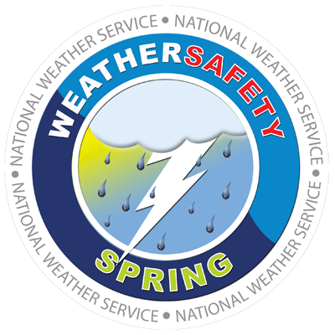

NOAA’s “Turn Around; Don’t Drown” Banner:
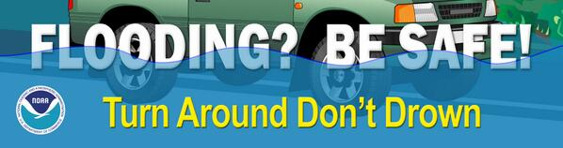

FEMA Region III’s Protect Against a Flood” Infographic
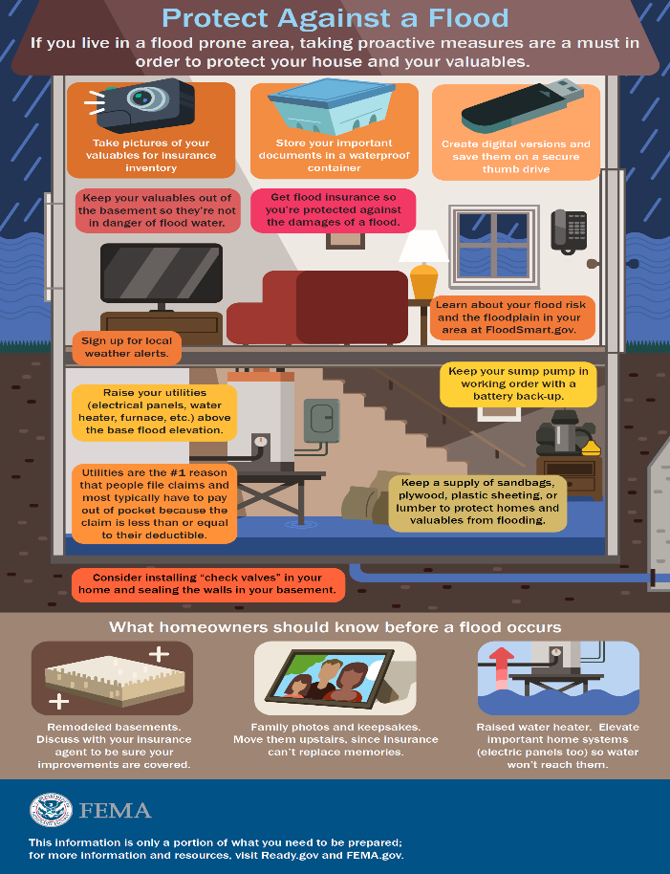
FEMA App (smartphone app for mobile devices)
The FEMA App contains disaster safety tips, interactive lists for storing your emergency kit, emergency meeting location information, and other disaster-specific information. The FEMA App also contains a new feature to its free app that will enable users to receive weather alerts from the National Weather Service for up to five locations across the U.S.
This new feature is valuable because it allows users to receive alerts on severe weather happening anywhere in the nation, even if the phone is not located in the area, making it easy for family and friends to help each other stay safe from across the nation. Weather alerts in the FEMA app also encourage users to take protective action by providing details on what to do to stay safe during severe weather.
The app is free to download through your smart phone provider’s app store on Android, Apple, and Blackberry devices.

Social Media
FEMA, Ready, NOAA, and FEMA Region III will have messages on their Facebook and Twitter accounts throughout the spring.
You may follow and echo the messaging from these accounts.
- FEMA Region III
  - Twitter
- FEMA HQ
  - Facebook
  - Twitter
- Ready
  - Facebook
  - Twitter
- NOAA
  - Facebook
  - Twitter
- NWS
  - Facebook
  - Twitter

Twitter Messaging
These messages are designed to be posted at any point during the spring to promote flood preparedness. Feel free to adapt the messages to suit your needs.
- Prepare before a #flood by installing a water alarm in your basement. More tips: http://1.usa.gov/1poPE5S #floodsafety
- 30: The number of days it takes for flood insurance to begin. Don’t wait until it’s too late! FloodSmart | The National Flood Insurance Program #floodsafety
- Spread #flood awareness in your community with these creative promotional tools! http://1.usa.gov/1tylAZ2 #floodsafety
- Get your organization prepared for a #flood with the flood playbook: http://1.usa.gov/1tylCzY #floodsafety
- Flooding is an increased risk if you live close to sea level! Know your risk and prepare! #floodsafety
- #TriviaTuesday: Anywhere it rains, it can flood. To be prepared for a flood, it’s important to be ready to evacuate quickly. #floodsafety
- How experienced are you in a flood situation? #CERT performs drills to ready the community! Read more at 1.usa.gov/1cowrMd
- When people talk about preparedness, they are more likely to take action, so start the conversation! #floodsafety
- Take action, get a kit. Make sure you have enough food, water and other supplies to last for at least 3 days. http://www.ready.gov/
- #Flood losses are not typically covered under renter and homeowner’s insurance policies. Consider flood insurance. http://floodsmart.gov
- Find out if your home or business is at risk for #flood and educate yourself on the impact it could have.FloodSmart | The National Flood Insurance Program
- There is a 30-day waiting period before #flood insurance goes into effect, so consider purchasing it now. FloodSmart | The National Flood Insurance Program
- Reduce the impact of #flooding; elevate the furnace, water heater and electric panel in your home. http://Ready.gov/floods
- Consider installing "check valves" to prevent flood water from backing up into the drains of your home. http://Ready.gov/floods
- # Flood fact: 2 feet of rushing water can carry away most vehicles including SUV’s and pick-ups. http://Ready.gov/floods
- # Flood fact: 6 inches of water will reach the bottom of most cars causing loss of control & possible stalling. http://Ready.gov/floods
- # Flood fact: Be aware of areas where floodwaters have receded. Roads may have weakened and could collapse under the weight of a car.
- Learning flood hazard terms will help you recognize and prepare for a flood. http://Ready.gov/floods
- Driving into floodwaters could be the last decision you ever make. http://youtu.be/eI6mIlHKrVY #FloodSafety
- 1 out of every 2 flood fatalities is vehicle-related. Turn Around Don’t Drown. tadd.weather.gov/#FloodSafety
- It is impossible to know how deep the water is just by looking at it. http://tadd.weather.gov/ #FloodSafety
- Learn the difference between a Flood Warning and Watch. http://www.floodsafety.noaa.gov/watch_warning.shtml #FloodSafety
- Go to http://water.weather.gov/ahps/ to find out if rivers near you are flooding #FloodSafety
Severe Weather
- Know #SevereWxPrep terms. Watches=severe weather is possible.
- Know #SevereWxPrep terms. Warnings=severe conditions have begun or will begin soon.
- Get alerts and warnings for impending weather events with a @NOAA Weather Radio. Learn more: nws.noaa.gov/nwr/ #SevereWxPrep
- Learn what alerts are available in your area, by doing an Internet search w/ your town, city or county name & the word alerts. #SevereWxPrep, #R3Ready
- Get a jump start on what to do before a #Tornado or #Flood by following #SevereWxPrep, @fema @ready
- Severe weather can strike any time of the year. Are you prepared? Follow @Readygov for updates. #SevereWxPrep
- Wireless Emergency Alerts are automatic texts sent to you in an emergency; no sign-up required: ready.gov/alerts #SevereWxPrep
- Sign-up for @Twitter Alerts from @FEMA for critical information in real-time: https://twitter.com/fema/alerts #SevereWxPrep
Tornado
- You may not always receive an official tornado alert so know the warning signs. Find them here: http://1.usa.gov/1r1pHQi #SevereWxPrep
- Funnel cloud, loud roar, & change in sky color are a few tornado warning signs. Learn others: http://1.usa.gov/1r1pHQi #SevereWxPrep
- Lightning and hail are common in tornado weather! Learn what else to expect. http://1.usa.gov/1r1pHQi #SevereWxPrep
- #Tornado Tip: A protective location in a sturdy bldg. is a small internal room w/out windows on lowest level or below ground. #SevereWxPrep
- Practice moving quickly to a protective location in the places where you spend a lot of time. #SevereWxPrep
- Tornadoes cause high winds which can knock out power. Be prepared by gathering supplies for each household member. #SevereWxPrep
- Tornado survivors say having a plan on where to take cover saved their life. Where will you take cover? http://bit.ly/1nwuDXu #SevereWxPrep
- Know where you would go to protect yourself in a #tornado at every place you spend a lot of time. #SevereWxPrep
- Know where to go if a Tornado Watch escalates to a Tornado Warning. Safe rooms and storm shelters save lives. #SevereWxPrep
- Don't get it twisted! Tornadoes can occur with almost no warning! Get prepared w/ http://1.usa.gov/1r1pHQi #SevereWxPrep
- Live in a tornado-prone area? Practice going to your protective location often. http://1.usa.gov/1r1pHQi #SevereWxPrep
Take Action
- Talk with your kids about #SevereWxPrep. Know the facts: http://go.usa.gov/3xkJF
- Make a plan to connect during severe weather by text, e-mail, social media & cell. #SevereWxPrep, #R3Ready.
- #SevereWxPrep tips: Only travel if necessary, keep phones charged, check on neighbors, & bring pets indoors.
- Pack an emergency kit for each person and pet traveling in your car in case evacuations are ordered: ready.gov/car #SevereWxPrep

Facebook Messaging
These messages are designed to be posted at any point during the spring to promote flood preparedness. Feel free to adapt the messages to suit your needs.
- Flooding is a nationwide threat to the United States and its territories throughout the year. It is important to for everyone to understand this risk and take action to prepare. #flood
- According to the National Weather Service (NWS) in 2016, there were 126 #flood fatalities in the Unities States and flooding caused approximately $10,906,740,000.00 US Dollars in damage. It is important to know if you are at risk.
- #Flood Fact: Six inches of water will reach the bottom of most passenger cars causing loss of control and possible stalling. #floodsafety
- #Flood Fact: A foot of water will float many vehicles. #floodsafety
- #Flood Fact: Two feet of rushing water can carry away most vehicles including sport utility vehicles (SUV’s) and pick-ups. #floodsafety
- #Flood Fact: Do not attempt to drive through a flooded road. The depth of water is not always obvious. The road bed may be washed out under the water, and you could be stranded or trapped. #floodsafety
- #Flood Fact: Do not drive around a barricade. Barricades are there for your protection. Turn around and go another way. #floodsafety
- #Flood Fact: Do not try to take short cuts. They may be blocked. Stick to designated evacuation routes. #floodsafety
- #Flood Fact: Be especially cautious driving at night when it is harder to recognize flood dangers. #floodsafety

Severe Weather
- Severe weather can strike at any time. Know the risk in your area and get prepared. ready.gov/severe-weather #SevereWxPrep
- During severe weather Wireless Emergency Alerts can save your life. Watch how: http://youtu.be/wDpcGypv2_U #SevereWxPrep
- Take time to talk with your family about #SevereWxPrep. For more tips and information visit: ready.gov/kids/know-the-facts
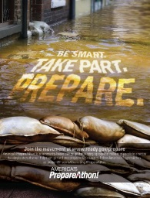
Instagram
Flood
- #Flooded with so much preparedness information you don’t know what to do? Make it simple and register with #PrepareAthon! #fightfloods #beprepared #prepping #BeAForce http://go.usa.gov/cyK4w
- Not sure what measures to take before a #flood happens? Register with #PrepareAthon! to get in the know. F#loodprep #prepper #Fightfloods http://go.usa.gov/cyK4w

Tornado
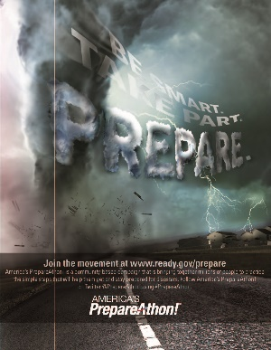
- What would you do in a #tornado? #Beprepared and register for #PrepareAthon! http://go.usa.gov/cyKBd
- Don’t be swept away in #tornado confusion! Keep your feet firmly planted and sign up with #PrepareAthon! http://go.usa.gov/cyKBd

Flood Awareness Tools
FEMA Resources:
- https://www.floodsmart.gov/floodsmart/pages/partner/tools_resources.jsp
- Mitigation Best Practices and Case Study Portfolio: http://www.fema.gov/mitigation-best-practices-portfolio
- https://www.youtube.com/playlist?list=PL720Kw_OojlJMho0p2z43G0zYm2VCiBWU (playlist on Preparing for an Emergency)
- https://www.youtube.com/playlist?list=PL720Kw_OojlLJPqgm3-7I9hIIaiDP-PGS (playlist on flooding PSAs)

Interactive Flood Risk Resources: For more information about floods, risk of financial loss due to flooding, and flood insurance check out
- The Cost of Flooding Tool
- Floodsmart.gov Tools and Resources
NOAA’s National Weather Service:
- National Seasonal Safety Campaign
“Turn Around, Don’t Drown” Resources:
http://www.nws.noaa.gov/om/water/tadd/signs.shtml

Training:
To promote Flood Safety Awareness, FEMA's Emergency Management Institute (EMI) has developed a series of training programs to encourage flood safety. This guide provides readers with an easy way to identify and access self-paced courses designed for people who have emergency management responsibilities and the general public.
- IS-909: Community Preparedness: Implementing Simple Ideas for Everyone
- IS-279.A: Introduction to Retrofitting Flood-Prone Residential Buildings
Publications:
FEMA has developed these resources to educate and inform communities about the importance of flood safety awareness.
- Spring Flooding: Risks and Protection: What You Should Know
- Flood After Fire Fact Sheet
- After a Flood: The First Steps. L-198. Information for homeowners on preparedness, safety and recovery from a flood.
- Homeowner’s Guide to Retrofitting: Six Ways to Protect Your House from Flooding.
- L-235. A brochure about obtaining information about how to protect your home from flooding.
- Homeowner’s Guide to Retrofitting: Six Ways to Protect Your House from Flooding. FEMA-312. A detailed manual on how to protect your home from flooding.
- Above the Flood: Elevating Your Floodprone House. FEMA-347. This publication is intended for builders, code officials and homeowners.
- Protecting Building Utilities from Flood Damage. FEMA-348. This publication is intended for developers, architects, engineers, builders, code officials and homeowners.

