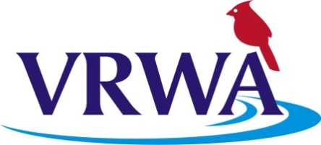
VIRGINIA RURAL WATER ASSOCIATION
Energy Efficiency Circuit Rider

The Virginia Rural Water Association has been given a grant for an Energy Efficiency Circuit Rider. The Energy Efficiency Circuit Rider (EFCR) role is to support the association’s goals and objectives related to assisting rural and small community water and wastewater utility systems in evaluating their energy needs, consumption and costs; recommending measures to reduce energy consumption; and identifying potential funding sources for improvements. The EFCR is required to travel to systems working on-site to perform energy efficiency assessments and to assist the utility in developing an energy efficiency plan for the future.

Job Requirements: High School Diploma or equivalent (GED) – Prior certification in energy efficiency audits/assessments or ability to obtain this certification within first quarter of employment – Must have a valid Virginia Driver’s License, reliable transportation and insurance – Team player – Basic computer skills – Great communication skills both written and verbal – Ability to work independently – Able to travel extensively throughout the state - Comfortable in public speaking – Comfortable in a training role on-site or in a formal classroom environment.

Excellent Benefits – health, dental insurance packets, 401K, plus more…Work from your home, VRWA provides the necessary tools to complete your duties and responsibilities.

Salary depending on qualifications – DOQ – Send resumes to Myrica Keiser, Virginia Rural Water Association, 2138 Sycamore Avenue, Buena Vista, VA 24416 or mkeiser@vrwa.org (no phone calls) EOE Drug-Free Workplace

