Stakeholder Toolkit
2019 Heat and Drought Preparedness Campaign

The Federal Emergency Management Agency (FEMA), and the Ready Campaign are teaming up this June to educate the public on heat safety and drought preparedness to ensure everyone is prepared for the summer heat.

Heat kills by pushing the human body beyond its limits. In extreme heat and high humidity, evaporation is slowed, and the body must work extra hard to maintain a normal temperature. According to the National Oceanic and Atmospheric Administration (NOAA), there were 108 heat related fatalities in 2018 with those over the age of 50 making up the majority of the fatalities. Heat has the highest 10-year average of deaths-per-year at 101 fatalities, and the highest 30-year average of any hazard at 136 fatalities.

During times of extreme heat, many areas may also experience periods of reduced rainfall or drought. As the summer continues and temperatures rise, there may be an increased risk of drought in our region. If a drought should occur, it’s important to know what measures to take to decrease the impact to yourself and property.

Throughout the month of June, FEMA will be raising awareness of how citizens can take steps to decrease their risk to both heat and drought. In addition to asking Americans to learn their risks and know what to do through its own outreach channels, FEMA Region III is encouraging everyone to get the word out and help the Whole Community prepare for heat and drought emergencies. This toolkit is designed to provide you and your organization with easy to use tools to promote this campaign and help your stakeholders be better prepared for disasters.

FEMA REGION III POINTS OF CONTACT

Public Affairs | Will Powell | 215-931-5684
Congressional and Intergovernmental Affairs | Nicholas Morici | 267-546-6419
Private Sector | Melissa Wiehenstroer | 202-568-4391
Volunteer Agency Liaison | Michelle Breeland | 215-931-5584
Community Preparedness | Carrie Weintraub | 267-515-3499
Regional Preparedness Liaison | John Dispaldo | 610-930-6869
Disability Integration | PJ Mattiacci | 267-270-5804

TALKING POINTS
- Heat waves can be dangerous and even life-threatening for humans who don't take the proper precautions.
- According to the National Oceanic and Atmospheric Administration (NOAA), there were 108 heat related fatalities in 2018. Heat also holds the highest 10-year average of 101 fatalities, and the highest 30-year average of any hazard at 136 fatalities.
- Most heat disorders occur because the victim has been overexposed to heat or has overexercised for his or her age and physical condition. Older adults, young children and those who are sick, or overweight are more likely to succumb to extreme heat.
- During times of extreme heat, many areas can also experience periods of reduced rainfall or drought. As the summer continues and temperatures rise, there may be an increased risk of drought in our region. If a drought should occur, it’s important to know what measures to take to reduce the impact to yourself and property.
- Nearly every part of our country experiences periods of reduced rainfall or drought. If we plan for drought, then we can enjoy the benefits of normal or rainy years and not be caught unprepared in dry years.

KEY MESSAGES

Heat Preparedness
- A heat wave is an extended period of extreme heat and can be accompanied by high humidity. These conditions can be dangerous and even life-threatening for humans who don't take the proper precautions.
- Know the Terms:
  - Heat Wave - A period of abnormally and uncomfortably hot and unusually humid weather. Typically, a heat wave lasts two or more days.
  - Heat Index - The Heat Index (HI) or the "Apparent Temperature" is an accurate measure of how hot it really feels when the Relative Humidity (RH) is added to the actual air temperature.
  - Heat Cramps - A condition that is marked by sudden development of cramps in skeletal muscles and that results from prolonged work or exercise in high temperatures accompanied by profuse perspiration with loss of sodium chloride from the body
  - Heat Exhaustion - A mild form of heat stroke, characterized by faintness, dizziness and heavy sweating
  - Heat Stroke - A life-threatening condition marked especially by cessation of sweating, extremely high body temperature, and collapse that results from prolonged exposure to high temperature — compare
  - Sun Stroke - Another term for heat stroke.
  - Excessive Heat Watch - Issued by the National Weather Service when heat indices in excess of 105ºF (41ºC) during the day combined with nighttime low temperatures of 80ºF (27ºC) or higher are forecast to occur for two consecutive days.
  - Excessive Heat Warning - Issued within 12 hours of the onset of the following criteria: heat index of at least 105°F for more than three hours per day for two consecutive days, or heat index more than 115°F for any period of time.
  - Heat Advisory - Issued within 12 hours of the onset of the following conditions: heat index of at least 105°F but less than 115°F for less than three hours per day, or nighttime lows above 80°F for 2 consecutive days.
- Before extreme heat occurs, it is important to take steps now to prepare;
  - Install window air conditioners snugly; insulate if necessary.
  - Check air conditioning ducts for proper insulation.
  - Install temporary window reflectors (for use between windows and drapes), such as aluminum foil-covered cardboard, to reflect heat back outside.
  - Weather-strip doors and sills to keep cool air in.
  - Cover windows that receive morning or afternoon sun with drapes, shades, awnings or louvers. (Outdoor awnings or louvers can reduce the heat that enters a home by up to 80 percent.)
  - Keep storm windows up all year.
  - Listen to local weather forecasts and be aware of possible temperature changes.
  - Know those in your neighborhood who might be most at risk to excessive heat and may need help.
  - Be aware that people living in urban areas may be at greater risk from the effects of a prolonged heat wave than people living in rural areas.
  - Get trained in first aid to learn how to treat heat-related emergencies.
- What you should do if the weather is extremely hot:
  - Listen to NOAA Weather Radio for critical updates from the National Weather Service (NWS).
  - Never leave children or pets alone in closed vehicles.
  - Stay indoors as much as possible and limit exposure to the sun.
  - Stay on the lowest floor and out of direct sunshine if air conditioning is not available.
  - Postpone outdoor games and activities.
  - If you must be outside, protect yourself by using sunscreen on exposed skin.
  - Consider spending the warmest part of the day in temperature-controlled buildings such as libraries, schools, movie theaters, shopping malls and other community facilities.
  - Circulating air can cool the body by increasing the perspiration rate of evaporation.
  - Eat well-balanced, light and regular meals. Avoid using salt tablets unless directed to do so by a physician.
  - Drink plenty of water; even if you do not feel thirsty. Avoid drinks with caffeine. Persons who have epilepsy or heart, kidney or liver disease; are on fluid-restricted diets; or have a problem with fluid retention should consult a doctor before increasing liquid intake.
  - Limit intake of alcoholic beverages.
  - Dress in loose-fitting, lightweight and light-colored clothes that cover as much skin as possible. Avoid dark colors because they absorb the sun’s rays.
  - Protect your face and head by wearing a wide-brimmed hat.
  - Avoid strenuous work during the warmest part of the day. Use a buddy system when working in extreme heat and take frequent breaks.
  - Check on family, friends, and neighbors who do not have air conditioning and who spend much of their time alone.
  - Avoid extreme temperature changes.
  - Check on your animals frequently to ensure that they are not suffering from the heat.
  - Go to a designated public shelter if your home loses power during periods of extreme heat. Text SHELTER + your ZIP code to 43362 (4FEMA) to find the nearest shelter in your area (example: shelter 12345) and listen to your local officials for shelter locations.
- People living in urban areas may be at greater risk from the effects of a prolonged heat wave than those living in rural areas. Also, asphalt and concrete store heat longer and gradually release heat at night, which can produce higher nighttime temperatures known as the "urban heat island effect."
Drought Preparedness
- Strategies for drought preparedness focus mainly on water conservation. The below list of practices is some of the ways before a drought occurs one can act every day to help preserve this essential resource.
- Indoor Water Conservation Tips Prior to a Drought (General, Bathroom, Kitchen)
  - Never pour water down the drain when there may be another use for it. For example, use it to water your indoor plants or garden.
  - Repair dripping faucets by replacing washers. One drop per second wastes 2,700 gallons of water per year.
  - Check all plumbing for leaks and have any leaks repaired by a plumber.
  - Retrofit all household faucets by installing aerators with flow restrictors.
  - Install an instant hot water heater on your sink.
  - Insulate your water pipes to reduce heat loss and prevent them from breaking.
  - Install a water-softening system only when the minerals in the water would damage your pipes. Turn the softener off while on vacation.
  - Choose appliances that are more energy and water efficient.
  - Consider purchasing a low-volume toilet that uses less than half the water of older models. Note: In many areas, low-volume units are required by law.
  - Install a toilet displacement device to cut down on the amount of water needed to flush. Place a one-gallon plastic jug of water into the tank to displace toilet flow (do not use a brick, it may dissolve, and loose pieces may cause damage to the internal parts). Be sure installation does not interfere with the operating parts.
  - Replace your showerhead with an ultra-low-flow version.
  - Start a compost pile as an alternate method of disposing of food waste or simply dispose of food in the garbage. (Kitchen sink disposals require a lot of water to operate properly)
- Outdoor Water Conservation Tips Prior to a Drought (general, lawn, pool)
  - Check your well pump periodically. If the automatic pump turns on and off while water is not being used, you have a leak.
  - Plant native and/or drought-tolerant grasses, ground covers, shrubs and trees. Once established, plants adapted to your local climate do not need water as frequently and usually will survive a dry period without watering. Small plants require less water to become established. Group plants together based on similar water needs.
  - Install irrigation devices that are the most water efficient for each use, such as micro and drip irrigation, and soaker hoses.
  - Use mulch to retain moisture in the soil. Mulch also helps control weeds that compete with landscape plants for water.
  - Avoid purchasing recreational water toys that require a constant stream of water.
  - Avoid installing ornamental water features (such as fountains) unless they use re-circulated water.
  - Consider rainwater harvesting where practical.
  - Contact your local water provider for information and assistance.
  - Position sprinklers so water lands on the lawn and shrubs and not on paved areas.
  - Repair sprinklers that spray a fine mist. Most misting issues result from a pressure problem. Properly regulating pressure in an irrigation system will prevent misting.
  - Check sprinkler systems and timing devices regularly to be sure they operate properly.
  - Raise the lawn mower blade to at least 3 inches or to its highest level. A higher cut encourages grass roots to grow deeper, shades the root system, and holds soil moisture.
  - Plant drought-resistant lawn seed. Reduce or eliminate lawn areas that are not used frequently.
  - Avoid overfertilizing your lawn. Applying fertilizer increases the need for water. Apply fertilizers that contain slow-release, water-insoluble forms of nitrogen.
  - Choose a water-efficient irrigation system such as drip irrigation for your trees, shrubs and flowers.
  - Turn irrigation down in fall and off in winter. Water manually in winter only if needed.
  - Put a layer of mulch around trees and plants to reduce evaporation and keep the soil cool. Organic mulch also improves the soil and prevents weeds.
  - Invest in a weather-based irrigation controller—or a smart controller. These devices will automatically adjust the watering time and frequency based on soil moisture, rain, wind, and evaporation and transpiration rates. Check with your local water agency to see if there is a rebate available for the purchase of a smart controller.
  - Install a new water-saving pool filter. A single back flushing with a traditional filter uses 180 to 250 gallons of water.
  - Cover pools and spas to reduce evaporation of water.

PRESS RELEASE TEMPLATE
<ORGANIZATION> is Encouraging Everyone to Know the Facts about Heat and Drought
Know the Facts. Know How to Act.
Heat and Drought Preparedness
June 2019

<CITY, St.> – <INSERT ORGANIZATION> is proud to join the Federal Emergency Management Agency (FEMA) to promote heat and drought preparedness by spreading the word and encouraging <employees or residents> and the rest of the community to learn the facts and taking steps now to prepare. <INSERT ORGANIZATION> is <INSERT EVENT INFORMATION HERE> or <committed to be a leader for emergency preparedness>.
This June, FEMA and the Ready Campaign will be educating the public on heat and drought preparedness to ensure everyone is prepared for the summer heat. There were 108 heat-related deaths in 2016 and heat has the highest 10-year average at 101 fatalities, but the highest 30-year average at 136 fatalities.
During times of extreme heat, many areas may also experience periods of reduced rainfall or drought. As the summer continues and temperatures rise, there may be an increased risk of drought in our region. If a drought should occur, it’s important to know what measure to take to reduce the impact to yourself and property.
<INSERT ORGANIZATION> will be raising awareness of how citizens can take steps to decrease their risk to both heat and drought through <INSERT STEPS TAKEN>. <INSERT ORGANIZATION> is committed to helping the Whole Community to prepare for both heat and drought emergencies.
More information on heat and drought can be found at <INSERT ORGANIZATION WEBSITE>,The National Weather Service heat website at https://www.weather.gov/safety/heat, Ready.gov or the Spanish-language web site Listo.gov.
# # #

SOCIAL MEDIA AND GRAPHICS
FEMA, Ready, and NOAA recommend using social media tools to promote the 2018 Heat and Drought Preparedness Campaign. You can promote the campaign and general preparedness through your own channels, or by promoting messages posted by the FEMA, Ready and NOAA accounts.
We have included some sample messages below that you can post on your own social media accounts to engage your friends/followers on heat and drought preparedness. More information and ideas on how to take action and be an example can be found on FEMA’s official Facebook or Twitter accounts, Ready’s official Facebook or Twitter accounts, NOAA’s official Facebook or Twitter, the National Weather Service’s official Facebook and Twitter account, or FEMA Region III’s Twitter account.

FEMA App (smartphone app for mobile devices)

The FEMA App contains disaster safety tips, interactive lists for storing your emergency kit, emergency meeting location information, and other disaster-specific information. The app is free to download through your smartphone provider’s app store on Android, Apple and BlackBerry devices.

Graphics and Outreach Tools

Additional graphics and outreach tools can be found at the following links:
- Extreme Heat Graphics
- National Weather Service Summer Safety Weather Ready Nation Outreach Materials
Hashtags

- #HeatSafety
- #BeatTheHeat
- #SummerSafety
- #HeatstrokeKills
- #KeepYourCool

Heat Safety and Risks

- Follow @NWS for heat advisories & excessive heat warnings so you can #BeatTheHeat this summer.
- Do you know the difference between a Heat Outlook, Watch, & Warning? Learn them today: https://www.weather.gov/safety/heat #BeatTheHeat
- Stay safe from the heat by drinking a lot of water, staying indoors, & calling 911 if you see someone suffering from a heat emergency: www.ready.gov/heat #BeatTheHeat
- When a child's temp reaches 107 degrees-they die. Call 911 & act fast if you see a child in danger. #HeatStrokeKills
- Extreme heat makes the body work extra hard to maintain a normal temperature. Know the facts & prepare: www.ready.gov/heat #HeatSafety
- Did you know that urban residences are at greater risk of the effects of prolonged #heat than rural and suburban residences? www.ready.gov/heat #HeatSafety
- For Facebook: Heat is typically the leading cause of weather-related fatalities each year. Heat waves have the potential to cover a large area, exposing a high number of people to a hazardous combination of heat and humidity, which can be very taxing on the body. Learn how to stay safe during a heat wave at www.weather.gov/heat #KeepYourCool #HeatSafety
- For Facebook: During extremely hot and humid weather, your body's ability to cool itself is challenged. When the body heats too rapidly to cool itself properly, or when too much fluid or salt is lost through dehydration or sweating, the body temperature will rise. As a result, you or someone you care about may experience a heat-related illness. Learn the symptoms of excessive heat exposure and the appropriate responses. weather.gov/safety/heat-illness #HeatSafety
- Learn the symptoms of excessive heat exposure and the appropriate responses.
weather.gov/safety/heat-illness #HeatSafety

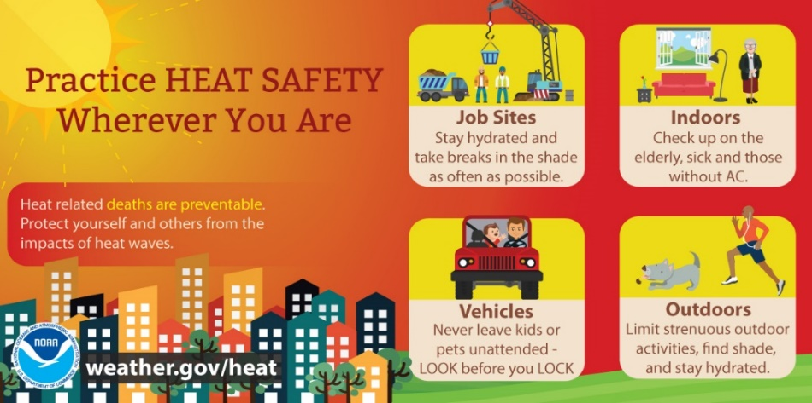
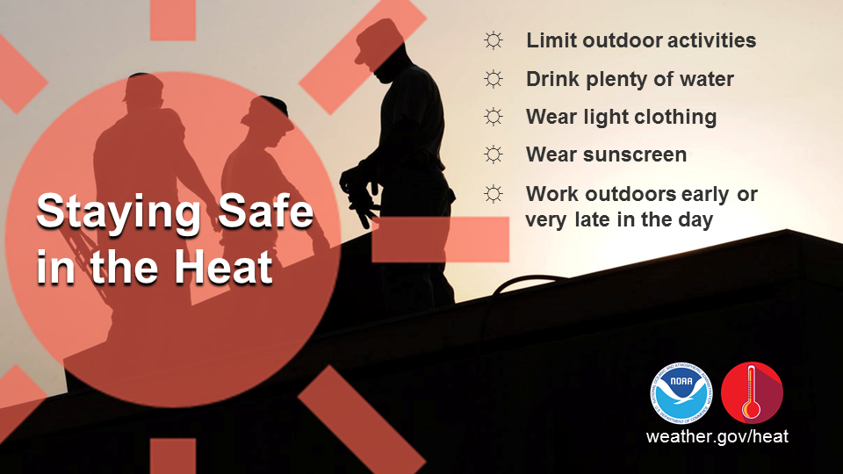

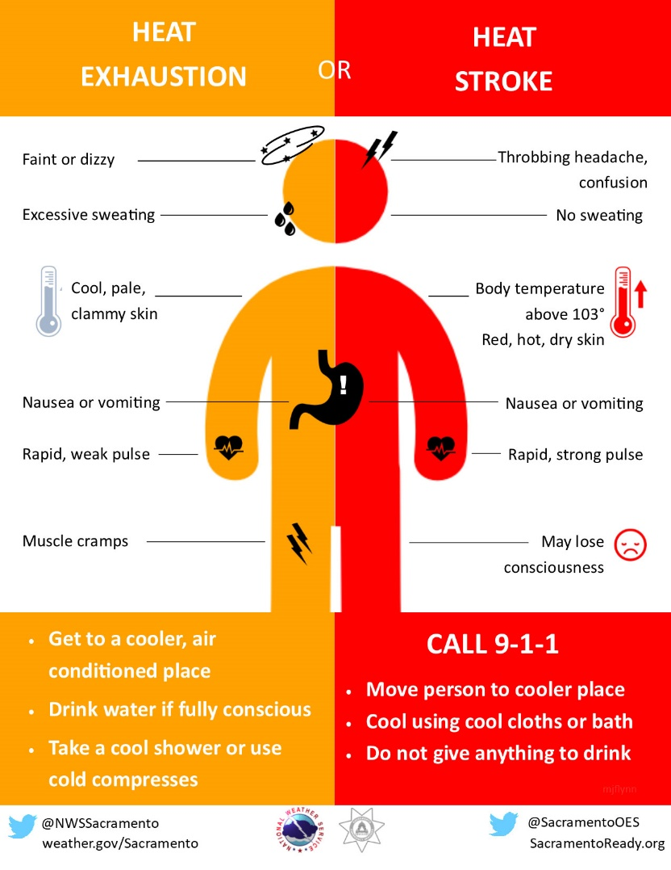

Stay Indoors

- Roughly 40% of unwanted heat buildup in our homes is through windows. Use awnings or curtains to keep the heat out! #BeatTheHeat
- #BeatTheHeat by staying indoors and in the shade. More tips for the entire family on www.ready.gov/kids/know-the-facts/extreme-heat #BeatTheHeat this summer!
- Tip: Check the weather stripping on doors and windows to keep the cool air in. #BeatTheHeat
- Extreme heat can often lead to #blackouts. Don't be in the dark, learn how to prepare at: www.ready.gov/power-outage #HeatSafety
- Fans alone aren’t enough in high heat + high humidity. Get inside in A/C or go to a public place like the library, museum or shopping mall to #BeatTheHeat
- Enter your ZIP code at www.211.org to find cooling-off centers near you! #SummerSafety #BeatTheHeat
- Contact your local Office of Emergency Management to find a cooling-off center near you. #BeatTheHeat

Reduce Heat Impact

- In extreme heat, dress in loose-fitting, lightweight and light-colored clothes. Avoid dark colors because they absorb the sun’s rays. #BeatTheHeat
- Check on your pets frequently to ensure they are safe during extreme heat. #BeatTheHeat
- Keep strenuous activity to a minimum during the hottest parts of the day (11am-2pm) and use a buddy system! #SummerSafety
- #BeatTheHeat tip: Check on seniors, people who are ill or may need extra help frequently.
- Make sure you drink LOTS of water to stay hydrated and prevent dehydration, heat stroke & more. #SummerSafety
- During extreme heat drink plenty of water, even if you don't feel thirsty. #HeatSafety
- Got heat cramps? Rest in a cool place & drink a beverage containing electrolytes and sodium, like a sports drink. #BeatTheHeat
- Recognize when someone is suffering from dehydration or heat stroke & act quickly! Learn the signs: https://www.cdc.gov/disasters/extremeheat/index.html #SummerSafety
- Video: #HeatSafety information and tips in American Sign Language #ASL #FunctionalNeeds #HardofHearing https://youtu.be/0DZFOJowvb8
- Too hot to play outside? www.ready.gov/kids offers plenty of games and activities that will help children learn and prepare for emergencies as they play! #SummerSafety
- Don’t forget about your pets. Share these tips from the Humane Society to keep pets safe in the heat: http://bit.ly/1RRltIL #BeatTheHeat
- Stay informed! Heat is among the highest weather-related killers in the United States.
- #KeepYourCool Reschedule or plan outdoor activities during cooler parts of the day.
- #StayHydrated out there. Drink from 2–4 cups of water every hour while working or exercising outside.
- People over 65 are vulnerable to heat. Visit elderly neighbors, friends and family members to make sure they’re cool and hydrated. #SummerSafety #HeatSafety #BeatTheHeat

Car Safety

- NEVER leave children or pets alone in hot vehicles! Heat can rise in a car, up to 20 degrees in just 10 minutes! #BeatTheHeat
- Even with the windows rolled down, only minutes in a hot car can be deadly for your pet! NEVER leave your pets in the car! #PetPreparedness #HeatSafety
- Heat related deaths ARE preventable! Look before you lock! http://www.weather.gov/heat #HeatstrokeKills #HeatSafety
- For Facebook: Never leave children, disabled or elderly adults or pets in parked vehicles. Studies have shown that the temperature inside a parked vehicle can rapidly rise to a dangerous level for children, pets and even adults. Leaving the windows slightly open does not significantly decrease the heating rate. The effects can be more severe on children because their bodies have not developed the ability to efficiently regulate internal temperature. weather.gov/safety/heat-children-pets #HeatSafety #LookBeforeYouLock
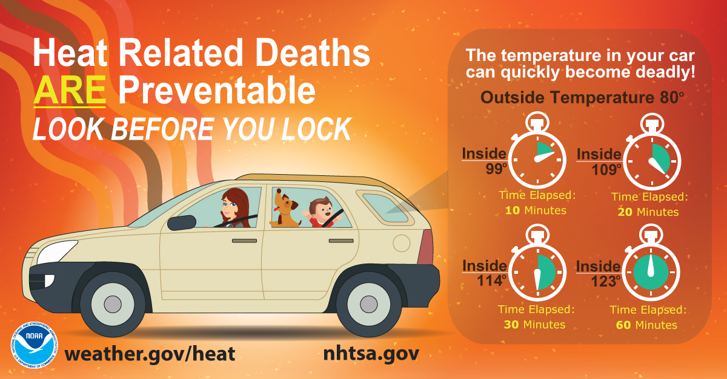

Urban Heat Islands

- Did you know that cities could be 7 degrees F warmer than neighboring grassy areas, such as farms or parks? #HeatScience https://earthobservatory.nasa.gov/blogs/eokids/
- DYK that cities could be 7 degrees F warmer than grassy areas, like farms or parks? #HeatScience #WorldEnvironmentDay https://earthobservatory.nasa.gov/blogs/eokids/
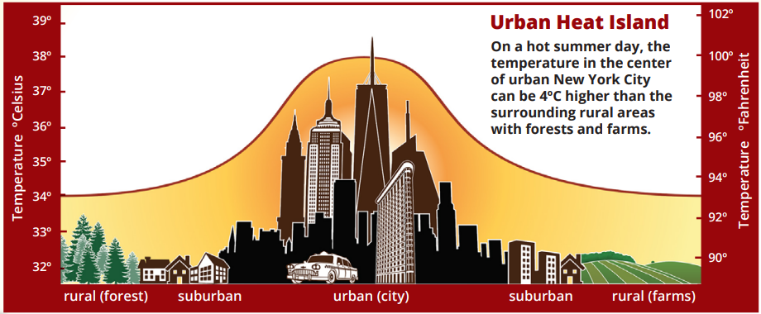

Heat Wave

- Heat wave: a period of abnormally hot & humid weather, lasting 2+ days. #KeepYourCool www.weather.gov/heat #HeatSafety #WorldEnvironmentDay
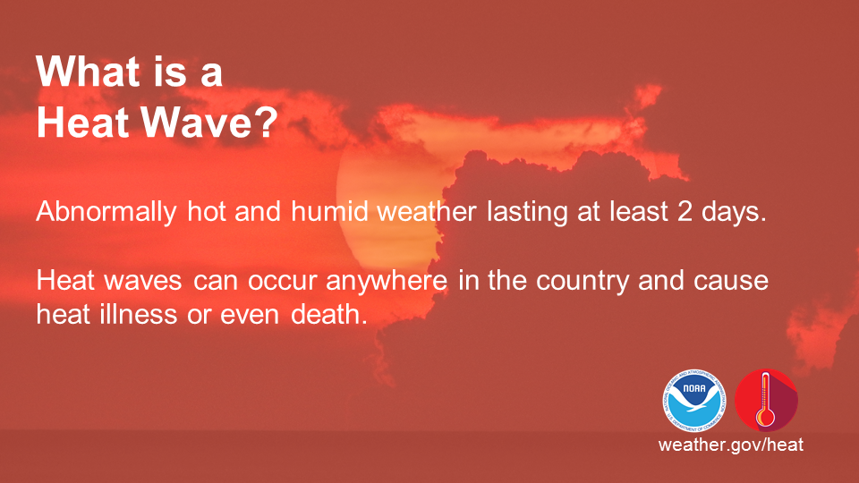
- For Facebook: Heat is typically the leading cause of weather-related fatalities each year. A heat wave is a period of abnormally hot and humid weather, generally lasting more than two days. Heat waves have the potential to cover a large area, exposing a high number of people to a hazardous combination of heat and humidity, which can be very taxing on the body. Learn how to stay safe during a heat wave at www.weather.gov/heatsafety #KeepYourCool #HeatSafety #WorldEnvironmentDay

Working and Playing Outside

- For Facebook: Protect yourself from the heat while working or playing outside. Drink plenty of water to stay hydrated and apply sunscreen regularly. Also, dress in lightweight and light-colored clothing and wear a wide-brimmed hat. www.weather.gov/heatsafety #KeepYourCool #HeatSafety
- For Facebook: When it is hot, wear lightweight, loose-fitting, light-colored clothing to reflect heat and sunlight. Hats are also a good idea to protect your face and scalp from harmful UV rays if you will be spending time directly in the sunshine. Apply sunscreen liberally. www.weather.gov/heatsafety #HeatSafety #KeepYourCool #WorldEnvironmentDay #OSHAISTHISOKAY
- Find out how to dress for the weather www.weather.gov/heatsafety #HeatSafety #KeepYourCool #WorldEnvironmentDay #OSHAISTHISOKAY
- For Facebook: Outdoor workers can be at a higher risk from the effects of excessive heat. When working under hot conditions, OSHA recommends #WaterRestShade as well as allowing more frequent breaks for new workers or workers who have been away from the job for a week or more (acclimatization). Knowing symptoms, prevention and emergency response methods can help prevent heat-related illnesses and death. Check weather forecasts ahead of time to be better prepared. www.osha.gov/heat #OSHA #HeatSafety #WorldEnvironmentDay #OSHAISTHISOKAY
- Learn the four questions to ask before working outdoors. www.osha.gov/heat #HeatSafety #KeepYourCool #WorldEnvironmentDay #OSHAISTHISOKAY
- For Facebook: Four questions to ask yourself before working outdoors: Do you have enough water? Do you have temporary shade available? Do you know the symptoms of heat illness? Do you know who to call in an emergency? www.weather.gov/heatsafety www.osha.gov/heat #HeatSafety #KeepYourCool #WorldEnvironmentDay #OSHAISTHISOKAY
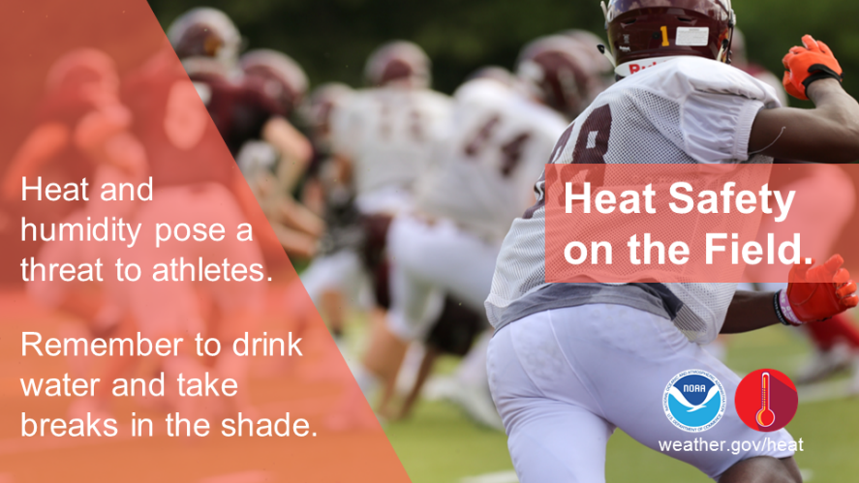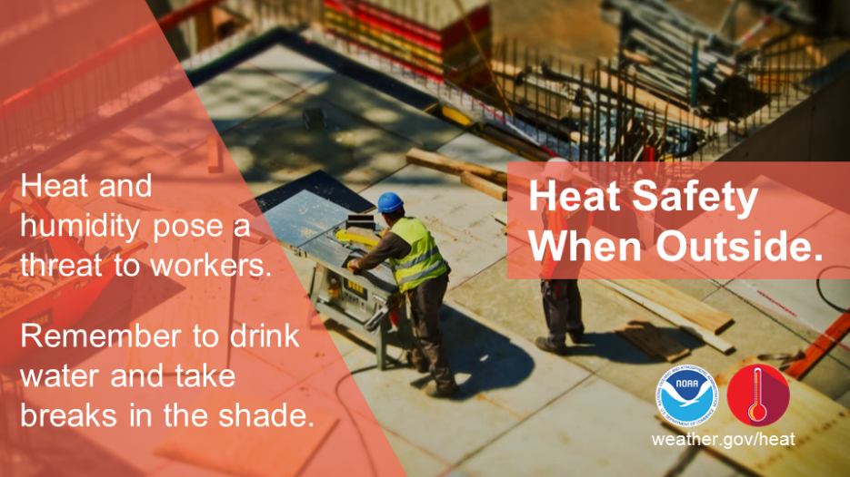
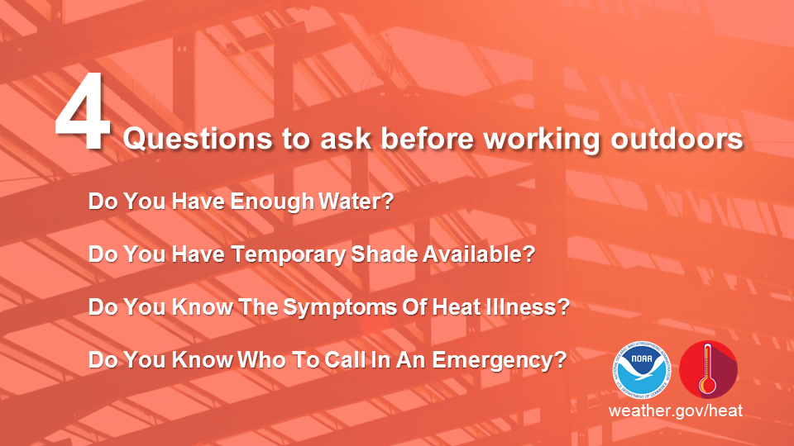

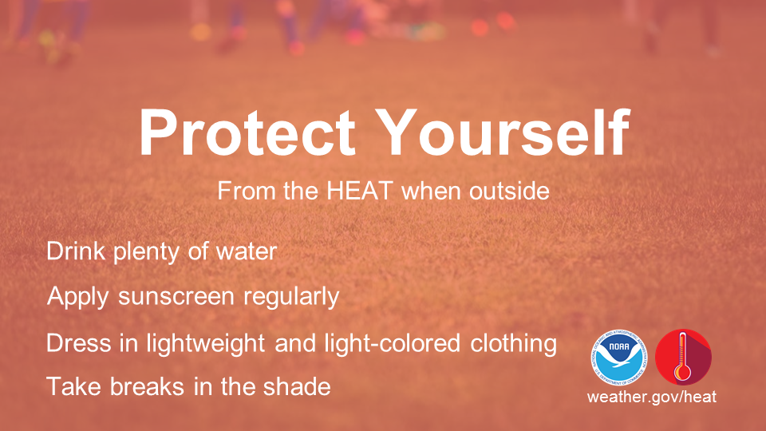

Sunburn Safety

- Spending time in the sun? Apply sunscreen and avoid heat related illness: www.weather.gov/heat #HeatSafety #SpringSafety
- For Facebook: Spending time in the sun on vacation this summer? Apply plenty of sunscreen! Also keep in mind that heat-related illness is a possibility if you don’t take certain precautions. Find out more about heat-related illnesses and how to prevent them at www.weather.gov/heat #HeatSafety #SpringSafety
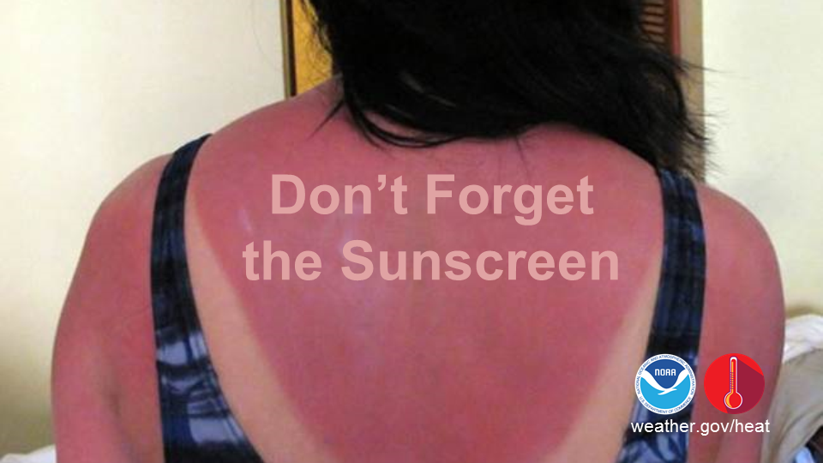

Heat Index

- The Heat Index tells you how hot it feels with humidity weather.gov/safety/heat-index #HeatSafety #SpringSafety
- For Facebook: Did you know the air temperature can actually feel hotter than what the thermometer reads? The Heat Index is a measure of how hot it really feels when relative humidity is factored in. This measurement is based on being in the shade, so it’s actually hotter directly in the sun. Find out what the Heat Index is by using the NWS Index chart below or the Heat Index calculator found at: weather.gov/safety/heat-index #HeatSafety #SpringSafety

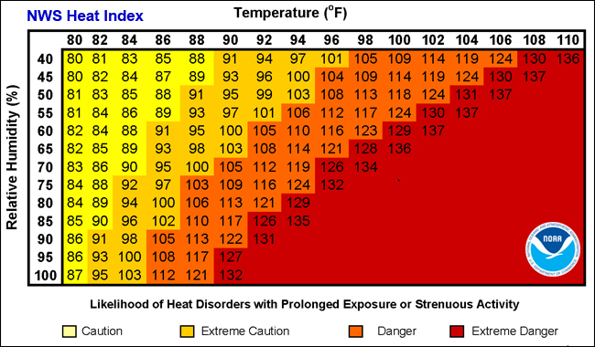

Indoor Water Conservation Tips, Prior to a Drought

- #WhenInDrought Never pour water down the drain when there may be another use for it. For example, use it to water your indoor plants or garden. #ConserveWater #SummerSafety #DroughtSafety
- #ConserveWater and Repair dripping faucets by replacing washers. 1 drop per second wastes 2,700 gallons of water a year. #WhenInDrought #WeatherReady #SummerSafety #DroughtSafety
- Insulate your water pipes to reduce heat loss and prevent them from breaking. #WhenInDrought #SummerSafety #DroughtSafety #ConserveWater
- Choose appliances that are more energy and water efficient. #WhenInDrought #SummerSafety #DroughtSafety #ConserveWater #sustainability
- Consider purchasing a low-volume toilet that uses less than half the water of older models. Note: In many areas, low-volume units are required by law. #WhenInDrought #SummerSafety #DroughtSafety #ConserveWater
- Start a compost pile as an alternate method of disposing of food waste or simply dispose of food in the garbage. #WhenInDrought #DroughtSafety #ConserveWater #PrepGardening

Outdoor Water Conservation Tips, Prior to a Drought

- Plant native and/or drought-tolerant grasses, ground covers, shrubs and trees. Once established, plants adapted local climate usually will survive a dry period. #WhenInDrought #SummerSafety #DroughtSafety #ConserveWater #PrepGardening
- Use mulch to retain moisture in soil. Mulch helps control weeds that compete with plants for water. #WhenInDrought #DroughtSafety #ConserveWater #PrepGardening
- Consider rainwater harvesting where practical. #WhenInDrought #SummerSafety #DroughtSafety #ConserveWater #PrepGardening #RainGardening
- Raise the lawn mower blade to at least 3 inches or to its highest level. A higher cut encourages grass roots to grow deeper, shades the root system, and holds soil moisture. #WhenInDrought #SummerSafety #DroughtSafety #ConserveWater #PrepGardening
- Put a layer of mulch around trees and plants to reduce evaporation and keep the soil cool. Organic mulch also improves the soil and prevents weeds. #WhenInDrought #SummerSafety #DroughtSafety #ConserveWater #PrepGardening
- Cover pools and spas to reduce evaporation of water. #WhenInDrought #SummerSafety #DroughtSafety #ConserveWater #PrepGardening

During a Drought

- For Facebook: Always observe state and local restrictions on water use during a drought. If restricted, for example, do not water your lawn, wash your car or other nonessential uses, to help ensure there is enough water for essential uses. Contact your state or local government for current information and suggestions.
- Avoid taking baths—take short showers—turn on water only to get wet and lather and then again to rinse off. #WhenInDrought #SummerSafety #DroughtSafety #ConserveWater
- Avoid letting the water run while brushing your teeth, washing your face or shaving. #WhenInDrought #SummerSafety #DroughtSafety #ConserveWater
- Avoid over watering your lawn and water only when needed #SummerSafety #DroughtSafety #WhenInDrought #SummerSafety #DroughtSafety #ConserveWater #PrepGardening
- A heavy rain eliminates the need for watering for up to two weeks. Most of the year, lawns only need 1 inch of water per week #SummerSafety #DroughtSafety #WhenInDrought #SummerSafety #DroughtSafety #ConserveWater #PrepGardening
- If your lawn does require watering, do so early in the morning or later in the evening, when temperatures are cooler. #WhenInDrought #SummerSafety #DroughtSafety #ConserveWater #PrepGardening
- Conserve water, practice fire prevention, and follow directions from local officials - watch this video to know exactly what to do during drought conditions: youtu.be/jni8YDoRP5o #SummerSafety #DroughtSafety
- When your hometown is suffering from drought conditions, do you know what to do? Visit the National Weather Service Drought Safety page to find out how you can help! weather.gov/drought #DroughtSafety #SummerSafety

Drought Climate
- Drought is a normal feature of our climate and can happen nearly everywhere. Learn what to do here: https://drought.gov #DroughtSafety #SummerSafety
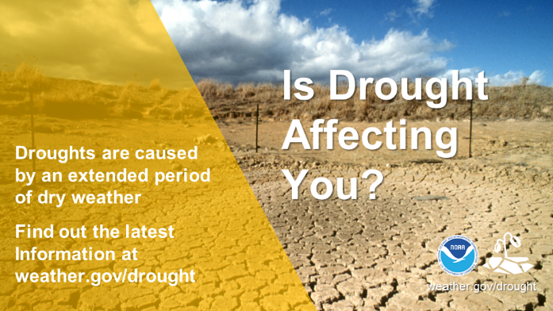
- For Facebook: Drought is a normal feature of our climate. Caused by a lack of rain or snow over an extended period, it can happen nearly everywhere. In some cases, drought can develop relatively quickly and last only for a very short period of time, exacerbated by extreme heat and/or wind. For other cases, drought can span multiple years or even decades. Where is the drought? Will it change? What are its impacts? Find answers to these questions at https://drought.gov #DroughtSafety #SummerSafety

Drought Meter

- For Facebook: How is drought affecting where you live? Check the Drought Meter. Enter your ZIP code for current conditions. https://www.drought.gov/drought/drought-my-backyard #DroughtSafety #SummerSafety
- How is drought affecting where you live? https://www.drought.gov/drought/drought-my-backyard #DroughtSafety #SummerSafety
